ADS

Assignment 2

**Exploratory Data analysis: (20 points)**

1. Write a Jupyter notebook using R/Python to graphically represent different summaries of data. Summarize your findings in this notebook.

Team 04:-Generating graph for following.

1. Generate the Graph for Number of application over the year.
2. Delinquency percentage over the year.
3. Purpose of application over year
4. Rejected number of application over the year.
5. ROI category over the year.
6. Amount over the year.
7. Generate the Graph for Number of application over the year: -

Every year application are increasing. From 2014 to 2015 there are significant increase in application. Graph shows the application received per year.

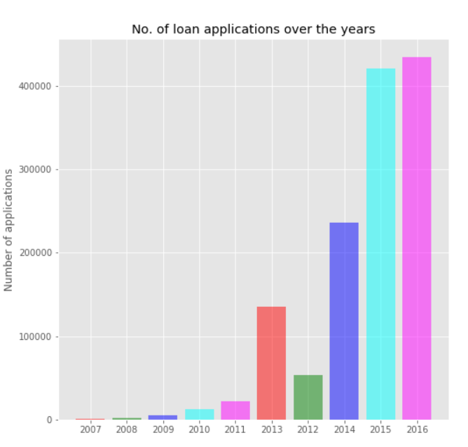

1. Delinquency percentage over the year:-Graph shows delinquent percentage over the years. Green color indicates to Delinquent No and blur color shows Delinquent Yes. There is a field …… in data set. If value is greater than Zero then we have counted as delinquent yes. If the value is zero then we counted as delinquent no.

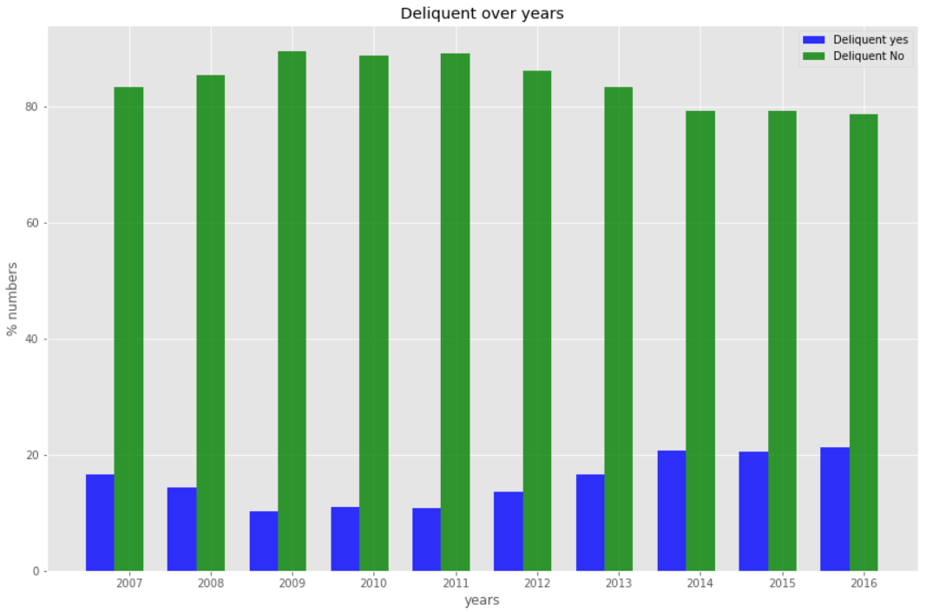

1. Purpose of application over year: - It is important to know purpose of the loan.

So we have generated the graph from 2007 to 2016.In recent year, meager purpose are debt consolidation. Also other significant purpose are small business, home improvement, wedding and etc.

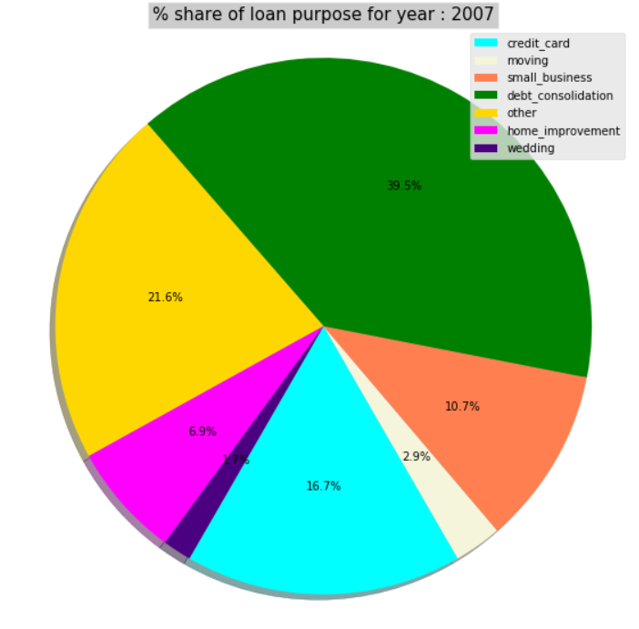

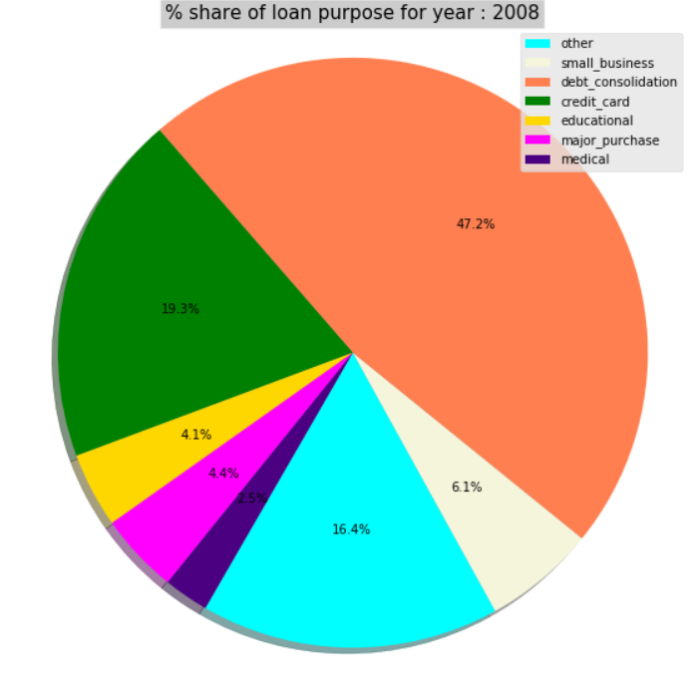

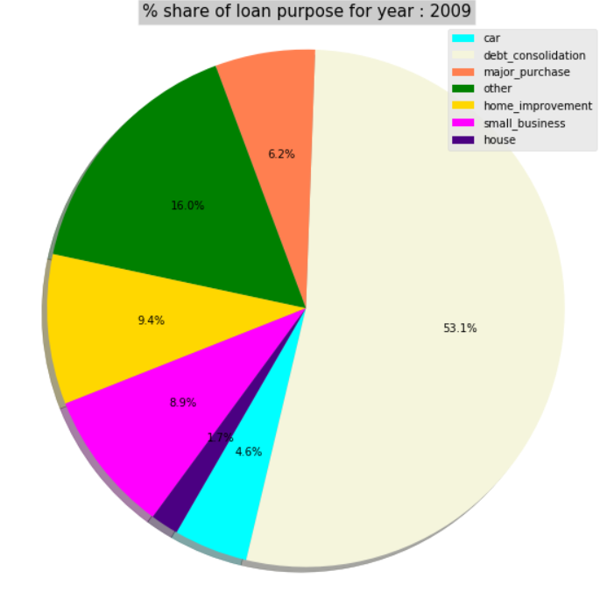

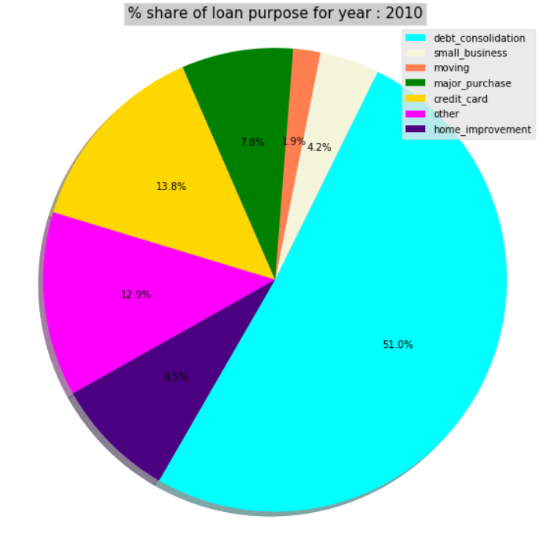

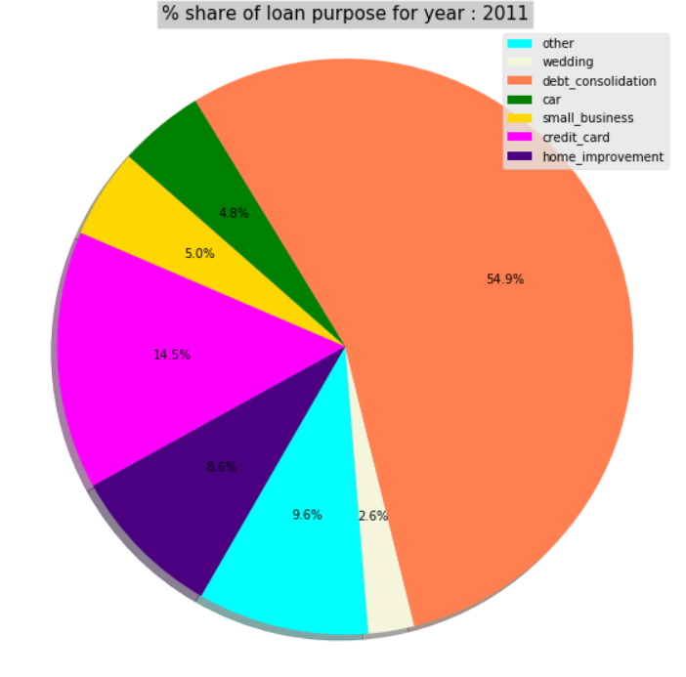

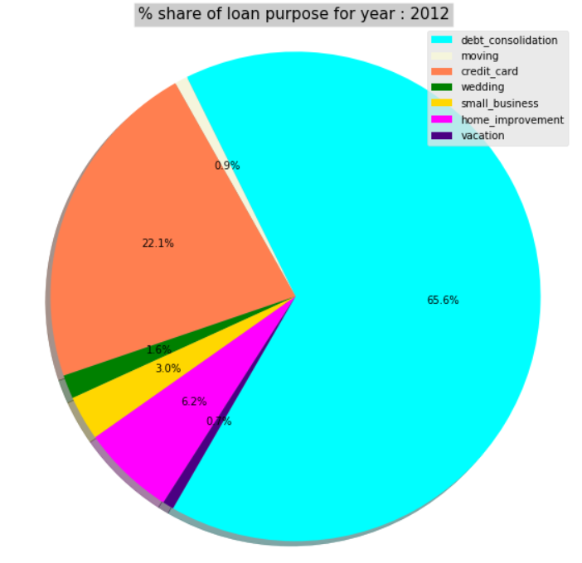

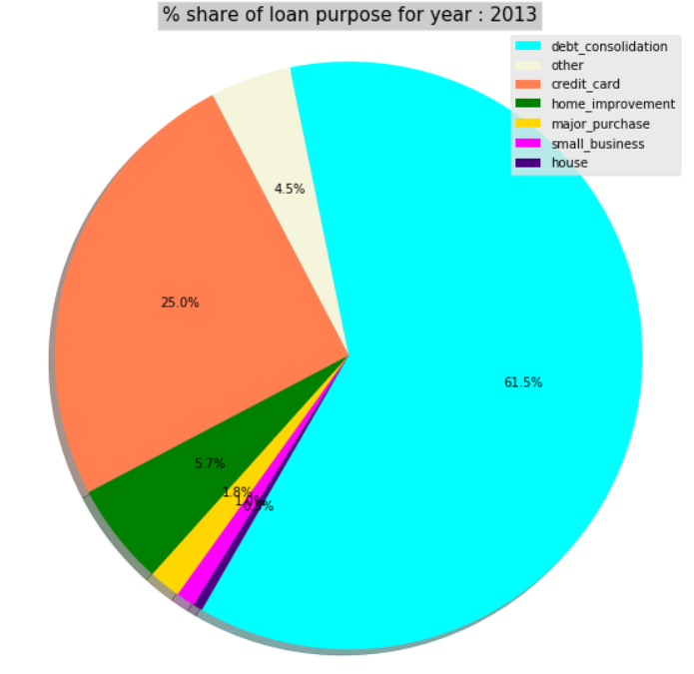

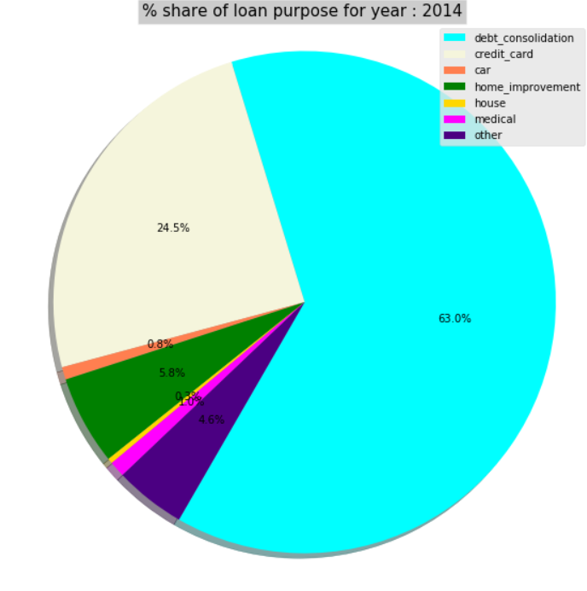

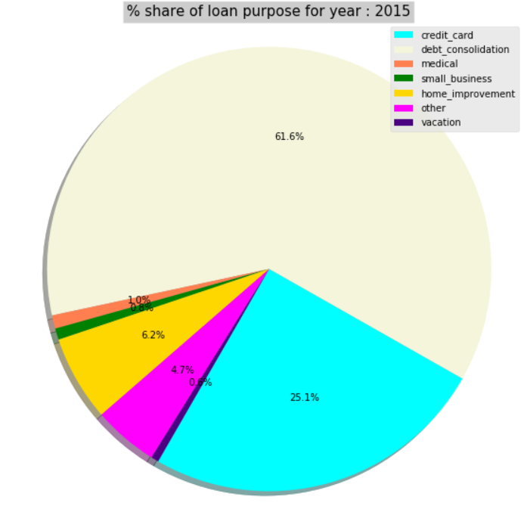

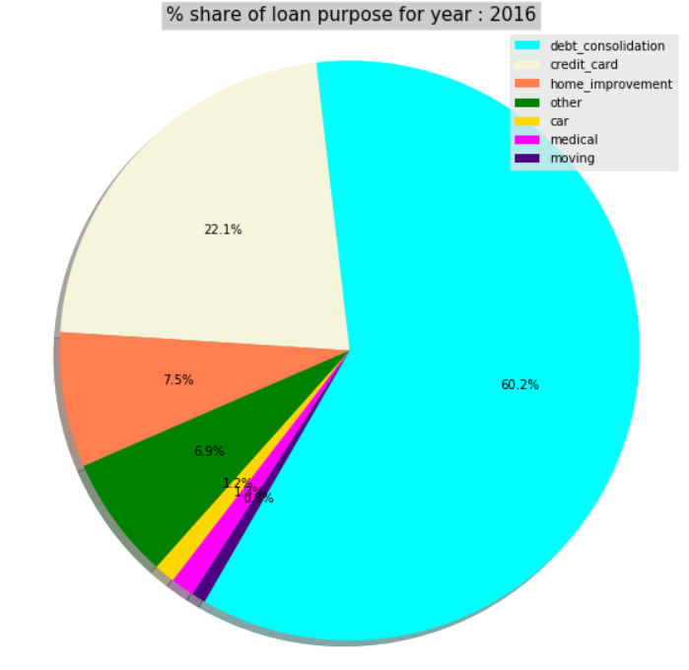

1. Rejected number of application over the year: - Number of application rejected over the years. Number of rejected applications are increasing over the years.

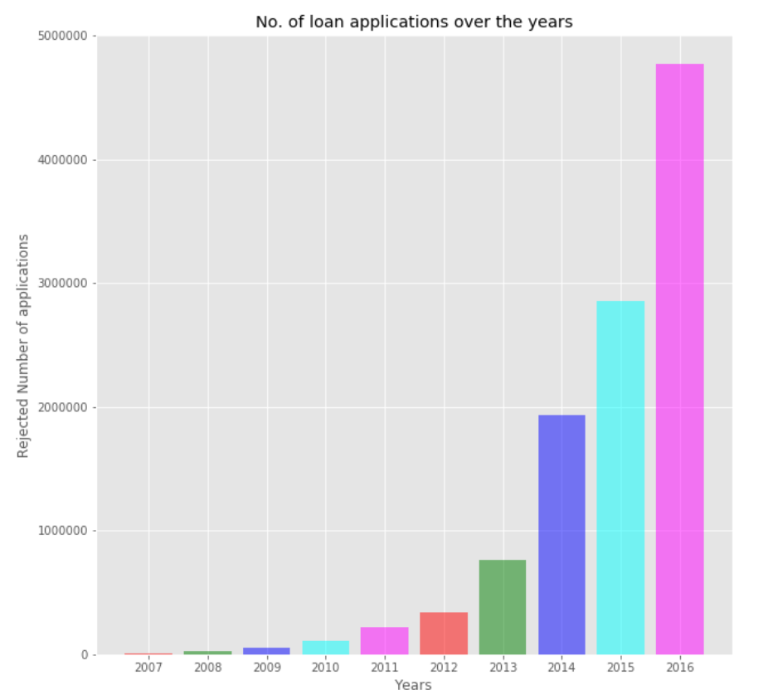

5) ROI category over the year: - ROI varies from 5 to 35. We have created the category for ROI. 5-10, 11-15, 16-20 and etc. Iterate over the data set and count the values for each category. Generated the graph from 2007 to 2016.Maximum time people got ROI from 11 to 15.

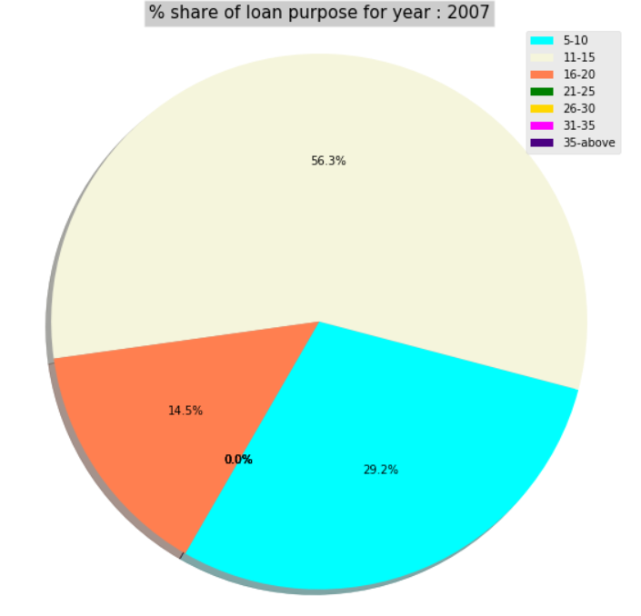

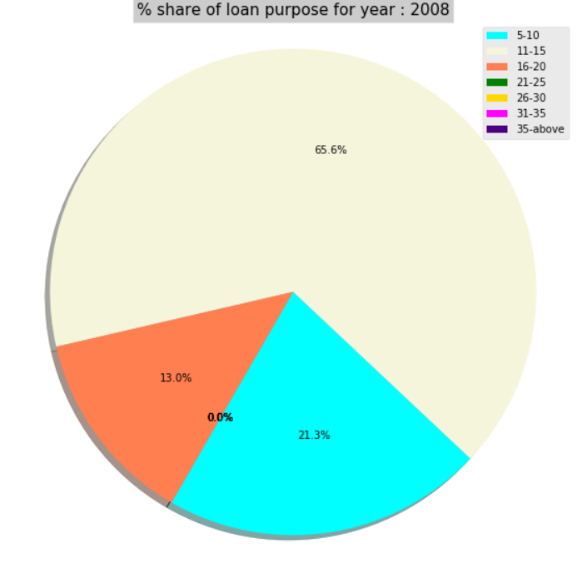

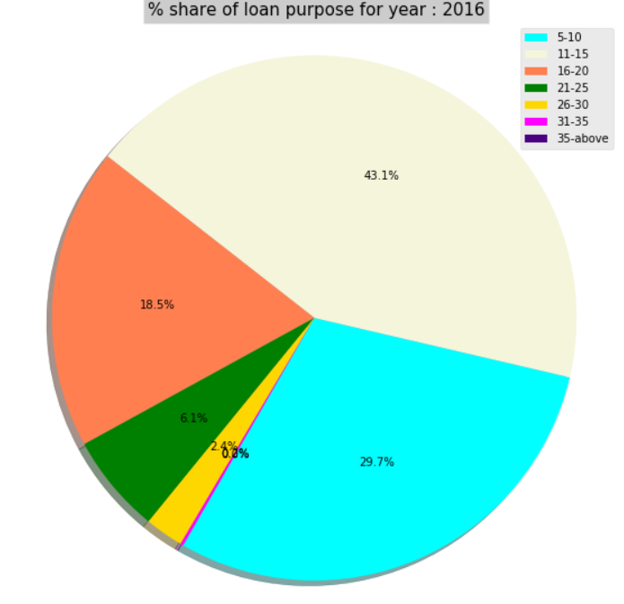

6) Amount over the year: - Majority of people requests for amount 1001 to 1000. Generated the graph from 2007 to 2016 years to see and find out the range or category for which people request most. In year 2016, majority of people requested the loan for 1000 to 20000.

